CPE301 – SPRING 2020

MIDTERM 2

Student Name: Xianjie Cao

Student #: 5004222179

Student Email: [caox2@unlv.nevada.edu](mailto:caox2@unlv.nevada.edu)

Primary Github address: <https://github.com/c1029324620/Mocha.git>

Directory: Mocha/Midterm2

1. **COMPONENTS LIST AND CONNECTION BLOCK DIAGRAM w/ PINS**

Atmel Studio 7: Debugger, simulator and assembler

Atmega328pb Xmini-PC

DC motor with decoder

Breadboard

Jump wires

Arduino multi-functional shield

TB6612FNG

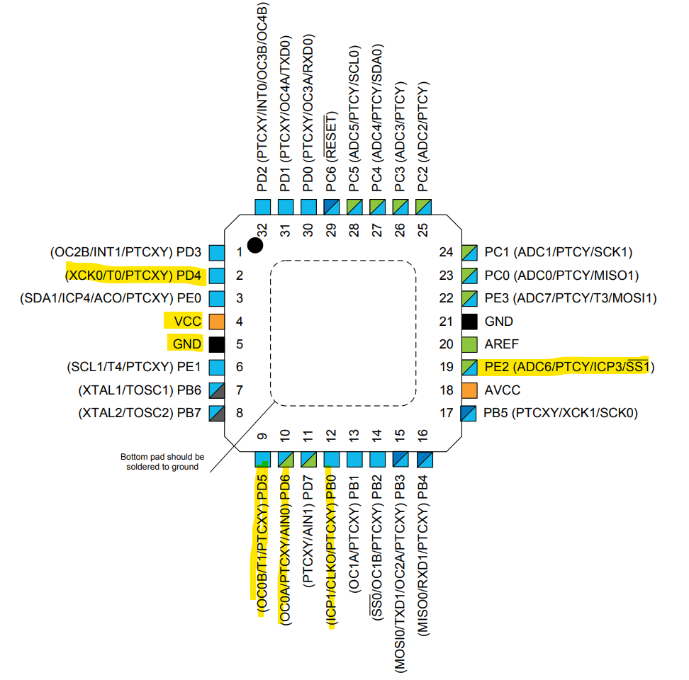

1. **INITIAL/MODIFIED/DEVELOPED CODE OF TASK 1/A**

Task 1:

/*

* Task1.c

*

* Created: 4/8/2020 10:34:53 AM

* Author : c1029

*/

#define *F_CPU* 16000000UL

#include <avr/io.h>

#include <util/delay.h>

int main(void)

{

int Flag;

DDRD |= (1<< DDRD4) | (1<< DDRD5) | (1<< DDRD6); //make PD4,PD5, and PD6 as outputs.

OCR0A = 128; //50% duty cycle

TCCR0A |= (1<< COM0A1) | (1<<WGM01) | (1<< WGM00); //non-inverting and fast PWM

TCCR0B |= (1<< CS00); //no prescaler.

/* Replace with your application code */

while (1)

{

if(Flag == 1)

{

PORTD|=(1<<DDD5);// CW Direction Set

PORTD&=~(1<<DDD4);// CW Direction Set

*_delay_ms*(5000);

Flag = 0;

}

else

{

PORTD&=~(1<<DDD5);// CCW Direction Set

PORTD|=(1<<DDD4);// CCW Direction Set

*_delay_ms*(5000);

Flag = 1;

}

}

}

1. **DEVELOPED MODIFIED CODE OF TASK 2/A from TASK 1/A**

Task 2:

/*

* Task2.c

*

* Created: 4/8/2020 1:29:52 PM

* Author : c1029

*/

#define *F_CPU* 16000000UL

#include <avr/io.h>

#include <util/delay.h>

unsigned int adc_value;

void init_adc()

{

ADMUX = (0<<REFS1) | //AVref

(1<<REFS0) |

(1<<ADLAR) | //Left justified

(0<<MUX2) | //ADC0 channel 0

(0<<MUX1) |

(0<<MUX0);

ADCSRA = (1<<ADEN) | //Enable ADC

(0<<ADSC) |

(0<<ADATE)|

(0<<ADIF) |

(0<<ADIE) |

(1<<ADPS2)| //prescaler of 128

(1<<ADPS1)|

(1<<ADPS0);

}

void read_adc()

{

ADCSRA |= (1 << ADSC); //enable start conversion

while(ADCSRA & (1<< ADSC)); //wait

adc_value = ADCH; // potentiometer value stored in adc_value

}

int main(void)

{

int Flag = 1;

init_adc();

DDRD |= (1<< DDRD4) | (1<< DDRD5) | (1<< DDRD6); //make PD4,PD5, and PD6 as outputs.

TCCR0A |= (1<< COM0A1) | (1<<WGM01) | (1<< WGM00); //non-inverting and fast PWM

TCCR0B |= (1<< CS00); //no prescaler.

/* Replace with your application code */

while (1)

{

read_adc();

OCR0A = adc_value; //duty cycle are based on the adc value read.

if(Flag == 1)

{

PORTD|=(1<<DDD5);// CW Direction Set

PORTD&=~(1<<DDD4);// CW Direction Set

*_delay_ms*(5000);

Flag = 0;

}

else

{

PORTD&=~(1<<DDD5);// CCW Direction Set

PORTD|=(1<<DDD4);// CCW Direction Set

*_delay_ms*(5000);

Flag = 1;

}

}

}

Task 3:

/*

* Task3.c

*

* Created: 4/8/2020 1:50:39 PM

* Author : c1029

*/

#define *F_CPU* 16000000UL

#define BAUD 9600

#include <avr/io.h>

#include <util/setbaud.h>

#include <stdlib.h>

#include <stdio.h>

#include <util/delay.h>

#include <avr/interrupt.h>

int Flag = 0;

unsigned long revTick = 0;

unsigned long Capt2 = 0;

unsigned long Capt3 = 0;

unsigned long Capt4 = 0;

//uint32_t T1Ovs1 = 0;

//uint32_t T1Ovs2 = 0;

//uint32_t T1Ovs3 = 0;

//uint32_t T10vs4 = 0;

unsigned overflow_cnt= 0;

int speed = 0;

unsigned long PulseWidth, Period;

volatile float DutyCycle;

unsigned int adc_value;

void USART_init(void)

{

UBRR0H = *UBRRH_VALUE*;

UBRR0L = *UBRRL_VALUE*;

UCSR0C = _BV(UCSZ01) | _BV(UCSZ00); //8-bit data

UCSR0B = _BV(RXEN0) | _BV(TXEN0); //enable receiver and transmitter

}

void USART_tx_string(char* data)

{

while((*data !='\0'))

{

while(!(UCSR0A & (1<<UDRE0)));

UDR0 = *data;

data++;

}

}

void adc_read()

{

ADCSRA |= (1 << ADSC); //enable start conversion

while(ADCSRA & (1<< ADSC)); //wait

adc_value = ADCH; // potentiometer value stored in adc_value

}

void display_adc()

{

adc_read();

char array1[32];

*sprintf*(array1,"%i", adc_value); //convert int to string

USART_tx_string("ADC Value: "); //print

USART_tx_string(array1);

USART_tx_string("\n");

}

void display_duty()

{

char array1[32];

*sprintf*(array1,"%f", DutyCycle); //convert int to string

USART_tx_string("Duty Cycle: "); //print

USART_tx_string(array1);

USART_tx_string("\n");

}

void display_period()

{

char array1[32];

*sprintf*(array1,"%lu", Period); //convert int to string

USART_tx_string("Period: "); //print

USART_tx_string(array1);

USART_tx_string("\n");

}

void display_pulse()

{

char array1[32];

*sprintf*(array1,"%lu", PulseWidth); //convert int to string

USART_tx_string("Pulsewidth: "); //print

USART_tx_string(array1);

USART_tx_string("\n");

}

void init_adc()

{

ADMUX = (0<<REFS1) | //AVref

(1<<REFS0) |

(1<<ADLAR) | //Left justified

(0<<MUX2) | //ADC0 channel 0

(0<<MUX1) |

(0<<MUX0);

ADCSRA = (1<<ADEN) | //Enable ADC

(0<<ADSC) |

(0<<ADATE)|

(0<<ADIF) |

(0<<ADIE) |

(1<<ADPS2)| //prescaler of 128

(1<<ADPS1)|

(1<<ADPS0);

}

void init_timer1()

{

DDRB &= ~(1<<DDB0);

PORTB |= (0<<DDB0);

TCNT1 = 0;

TCCR1A = 0;

TCCR1B = (0<<ICNC1) | (1<<ICES1); //RISING EDGE CAPTURE.

TCCR1C = 0;

TIFR1 =(1<<ICF1)|(1<<TOV1);// clear pending

TIMSK1 = (1<<ICIE1)|(1<<TOIE1);// and enable

}

void start_timer1()

{

//Start timer without prescaller

TCCR1B|=(1<< CS10);

}

void timer0_pwm()

{

DDRD |= (1<<DDD6);

TCNT0 = 0;

adc_read();

OCR0A = adc_value;

PORTD|=(1<<DDD5);// CW Direction Set

PORTD&=~(1<<DDD4);// CW Direction Set

TCCR0A |= (1<< COM0A1) | (1<<WGM01) | (1<< WGM00); //non-inverting and fast PWM

TCCR0B |= (1<< CS00) |(1<<CS02); //prescaler to 1024

}

void speed_rpm()

{

speed = (1/(Period* 0.0000000625)) * 60 /120L;

}

void display_speed()

{

char array1[20];

*sprintf*(array1,"%i", speed); //convert int to string

USART_tx_string("Speed: "); //print

USART_tx_string(array1);

USART_tx_string(" rpm\n");

}

int main(void)

{

init_adc();

timer0_pwm();

USART_init();

init_timer1();

start_timer1();

sei();

/* Replace with your application code */

//USART_tx_string("Connected\n");

while (1)

{

adc_read(); //update adc value

OCR0A = adc_value; //set speed.

if(Flag == 4)

{

Period= ((Capt3 - revTick + Capt4 - Capt2) / 2); //get the average period

PulseWidth = (Capt2 - revTick + Capt4 - Capt3) / 2; //get the average pulse width

DutyCycle = PulseWidth/(float)Period;

Flag = 0;

display_duty();

display_pulse();

speed_rpm(); //calculate speed in rpm.

display_period();

display_speed();

TCNT1 = 0;

overflow_cnt = 0;

*_delay_ms*(2000); //delay for printing result to terminal

TIMSK1|=(1<<ICIE1)|(1<<TOIE1);

}

}

}

//capture ISR

ISR(TIMER1_CAPT_vect)

{

//2x encoding

if(Flag == 0)

{

revTick = ICR1 + overflow_cnt * 65536;

//TCNT1=0;// restart timer for next revolution

//T1Ovs1=overflow_cnt;

TCCR1B&=~(1<<ICES1); //switch to falling edge

}

if(Flag == 1)

{

Capt2 = ICR1 + overflow_cnt * 65536;

TCCR1B|=(1<<ICES1); //switch back to rising edge

//T1Ovs2=overflow_cnt;

}

if(Flag ==2)

{

Capt3 = ICR1 + overflow_cnt * 65536;

TCCR1B&=~(1<<ICES1); //switch to falling edge

//T1Ovs3 = overflow_cnt;

}

if(Flag == 3)

{

Capt4 = ICR1 + overflow_cnt * 65536;

//T10vs4 = overflow_cnt;

TIMSK1&=~((1<<ICIE1)|(1<<TOIE1)); //stop input capture and overflow interrupt.

}

Flag++;

}

ISR(TIMER1_OVF_vect)

{

overflow_cnt++;

}

Task 4:

/*

* Task4.c

*

* Created: 4/8/2020 1:50:39 PM

* Author : c1029

*/

#define *F_CPU* 16000000UL

#define BAUD 9600

#include <avr/io.h>

#include <util/setbaud.h>

#include <stdlib.h>

#include <stdio.h>

#include <util/delay.h>

#include <avr/interrupt.h>

int Flag = 0;

int Flag_2 = 0;

unsigned long Cpa1 = 0;

unsigned long Capt2 = 0;

unsigned long Capt3 = 0;

unsigned long Capt4 = 0;

unsigned long Capt5 = 0;

unsigned long Capt6 = 0;

unsigned long Capt7 = 0;

unsigned long Capt8 = 0;

unsigned overflow_cnt= 0;

unsigned overflow_cnt_2 = 0;

int speed = 0;

unsigned long PulseWidth, Period;

volatile float DutyCycle;

unsigned int adc_value;

void USART_init(void)

{

UBRR0H = *UBRRH_VALUE*;

UBRR0L = *UBRRL_VALUE*;

UCSR0C = _BV(UCSZ01) | _BV(UCSZ00); //8-bit data

UCSR0B = _BV(RXEN0) | _BV(TXEN0); //enable receiver and transmitter

}

void USART_tx_string(char* data)

{

while((*data !='\0'))

{

while(!(UCSR0A & (1<<UDRE0)));

UDR0 = *data;

data++;

}

}

void adc_read()

{

ADCSRA |= (1 << ADSC); //enable start conversion

while(ADCSRA & (1<< ADSC)); //wait

adc_value = ADCH; // potentiometer value stored in adc_value

}

void display_adc()

{

adc_read();

char array1[32];

*sprintf*(array1,"%i", adc_value); //convert int to string

USART_tx_string("ADC Value: "); //print

USART_tx_string(array1);

USART_tx_string("\n");

}

void display_duty()

{

char array1[32];

*sprintf*(array1,"%f", DutyCycle); //convert int to string

USART_tx_string("Duty Cycle: "); //print

USART_tx_string(array1);

USART_tx_string("\n");

}

void display_period()

{

char array1[32];

*sprintf*(array1,"%lu", Period); //convert int to string

USART_tx_string("Period: "); //print

USART_tx_string(array1);

USART_tx_string("\n");

}

void display_pulse()

{

char array1[32];

*sprintf*(array1,"%lu", PulseWidth); //convert int to string

USART_tx_string("Pulsewidth: "); //print

USART_tx_string(array1);

USART_tx_string("\n");

}

void init_adc()

{

ADMUX = (0<<REFS1) | //AVref

(1<<REFS0) |

(1<<ADLAR) | //Left justified

(0<<MUX2) | //ADC0 channel 0

(0<<MUX1) |

(0<<MUX0);

ADCSRA = (1<<ADEN) | //Enable ADC

(0<<ADSC) |

(0<<ADATE)|

(0<<ADIF) |

(0<<ADIE) |

(1<<ADPS2)| //prescaler of 128

(1<<ADPS1)|

(1<<ADPS0);

}

void init_timer1()

{

DDRB &= ~(1<<DDB0); //PB0 as input for timer1 input capture

PORTB |= (0<<DDB0);

TCNT1 = 0;

TCCR1A = 0;

TCCR1B = (0<<ICNC1) | (1<<ICES1); //RISING EDGE CAPTURE.

TCCR1C = 0;

TIFR1 =(1<<ICF1)|(1<<TOV1);// clear pending

TIMSK1 = (1<<ICIE1)|(1<<TOIE1);// enable interrupt

}

void init_timer3()

{

DDRE &= ~(1<<DDE2); //PE2 as input for timer3 input capture

PORTE |= (0<<2);

TCNT3 = 0;

TCCR3A = 0;

TCCR3B = (0<<ICNC3) | (1<<ICES3); //rising edge capture.

TCCR3C = 0;

TIFR3 = (1<<ICF3) |(1<<TOV3); //clear pending

TIMSK3 = (1<<ICIE3)|(1<<TOIE3); //enable interrupt

}

void start_timer1()

{

//Start timer without prescaller

TCCR1B|=(1<< CS10);

}

void start_timer3()

{

TCCR3B |=(1<<CS30); //start timer3 without prescaller

}

void timer0_pwm()

{

DDRD |= (1<<DDD6);

TCNT0 = 0;

adc_read();

OCR0A = adc_value;

PORTD|=(1<<DDD5);// CW Direction Set

PORTD&=~(1<<DDD4);// CW Direction Set

TCCR0A |= (1<< COM0A1) | (1<<WGM01) | (1<< WGM00); //non-inverting and fast PWM

TCCR0B |= (1<< CS00) |(1<<CS02); //prescaler to 1024

}

void speed_rpm()

{

speed = (1/(Period* 0.0000000625)) * 60 /120L;

}

void display_speed()

{

char array1[20];

*sprintf*(array1,"%i", speed); //convert int to string

USART_tx_string("Speed: "); //print

USART_tx_string(array1);

USART_tx_string(" rpm\n");

}

int main(void)

{

init_adc();

USART_init();

init_timer1();

init_timer3();

start_timer1();

start_timer3();

timer0_pwm();

sei();

unsigned long period_1 = 0, period_2 = 0;

unsigned long PulseWidth_1 = 0, PulseWidth_2 = 0;

volatile float DutyCycle_1, DutyCycle_2;

/* Replace with your application code */

//USART_tx_string("Connected\n");

while (1)

{

adc_read(); //update adc value

OCR0A = adc_value; //set speed.

if(Flag == 4) //Ch.A finish capturing

{

period_1 =((Capt3 - Cpa1 + Capt4 - Capt2) / 2); //get the average period

PulseWidth_1 = (Capt2 - Cpa1 + Capt4 - Capt3) / 2; //get the average pulse width

DutyCycle_1 = PulseWidth_1/(float)period_1;

Flag++;

}

if(Flag_2 == 4) //Ch.B finish capturing

{

period_2 =((Capt7 - Capt5 + Capt8 - Capt6) / 2); //get the average period

PulseWidth_2 = (Capt6 - Capt5 + Capt8 - Capt7) / 2; //get the average pulse width

DutyCycle_2 = PulseWidth_2/(float)period_2;

Flag_2++;

}

if(Flag == 5 && Flag_2 == 5)

{

DutyCycle = (DutyCycle_1 + DutyCycle_2)/2;

Period = (period_1 + period_2) /2;

PulseWidth = (PulseWidth_1 + PulseWidth_2) /2;

display_duty();

display_pulse();

speed_rpm(); //calculate speed in rpm.

display_period();

display_speed();

Flag = 0;

Flag_2 = 0;

TCNT1 = 0;

TCNT3 = 0;

overflow_cnt = 0;

overflow_cnt_2 = 0;

*_delay_ms*(2000); //delay for printing result to terminal

TIMSK1|=(1<<ICIE1)|(1<<TOIE1);

TIMSK3|=(1<<ICIE3)|(1<<TOIE3); //restart interrupt.

}

}

}

//capture ISR

ISR(TIMER1_CAPT_vect)

{

//4x encoding

if(Flag == 0)

{

Cpa1 = ICR1 + overflow_cnt * 65536;

//TCNT1=0;// restart timer for next revolution

//T1Ovs1=overflow_cnt;

TCCR1B&=~(1<<ICES1); //switch to falling edge

}

if(Flag == 1)

{

Capt2 = ICR1 + overflow_cnt * 65536;

TCCR1B|=(1<<ICES1); //switch back to rising edge

//T1Ovs2=overflow_cnt;

}

if(Flag ==2)

{

Capt3 = ICR1 + overflow_cnt * 65536;

TCCR1B&=~(1<<ICES1); //switch to falling edge

//T1Ovs3 = overflow_cnt;

}

if(Flag == 3)

{

Capt4 = ICR1 + overflow_cnt * 65536;

//T10vs4 = overflow_cnt;

TIMSK1&=~((1<<ICIE1)|(1<<TOIE1)); //stop input capture and overflow interrupt.

}

Flag++;

}

ISR(TIMER3_CAPT_vect)

{

//4x encoding

if(Flag_2 == 0)

{

Capt5 = ICR3 + overflow_cnt_2 * 65536;

TCCR3B&=~(1<<ICES3); //switch to falling edge

}

if(Flag_2 == 1)

{

Capt6 = ICR3 + overflow_cnt_2 * 65536;

TCCR3B|=(1<<ICES3); //switch back to rising edge

}

if(Flag_2 ==2)

{

Capt7 = ICR3 + overflow_cnt_2 * 65536;

TCCR3B&=~(1<<ICES3); //switch to falling edge

}

if(Flag_2 == 3)

{

Capt8 = ICR3 + overflow_cnt_2 * 65536;

TIMSK3&=~((1<<ICIE3)|(1<<TOIE3)); //stop input capture and overflow interrupt.

}

Flag_2++;

}

ISR(TIMER3_OVF_vect)

{

overflow_cnt_2++;

}

ISR(TIMER1_OVF_vect)

{

overflow_cnt++;

}

1. **SCHEMATICS**

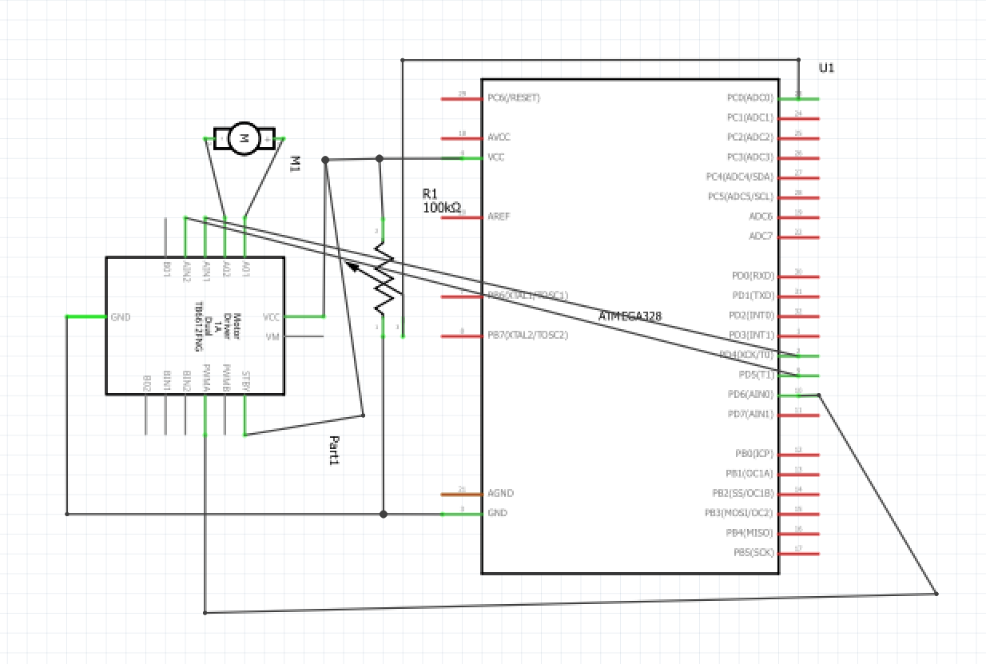

1. **SCREENSHOTS OF EACH TASK OUTPUT (ATMEL STUDIO OUTPUT)**

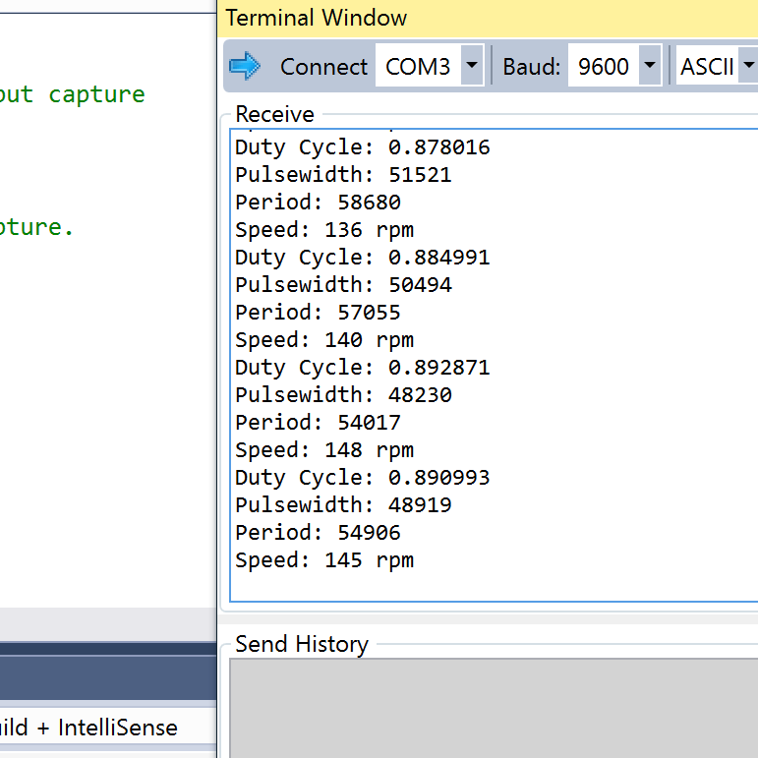

1. **SCREENSHOT OF EACH DEMO (BOARD SETUP)**

Task 1 and Task 2:

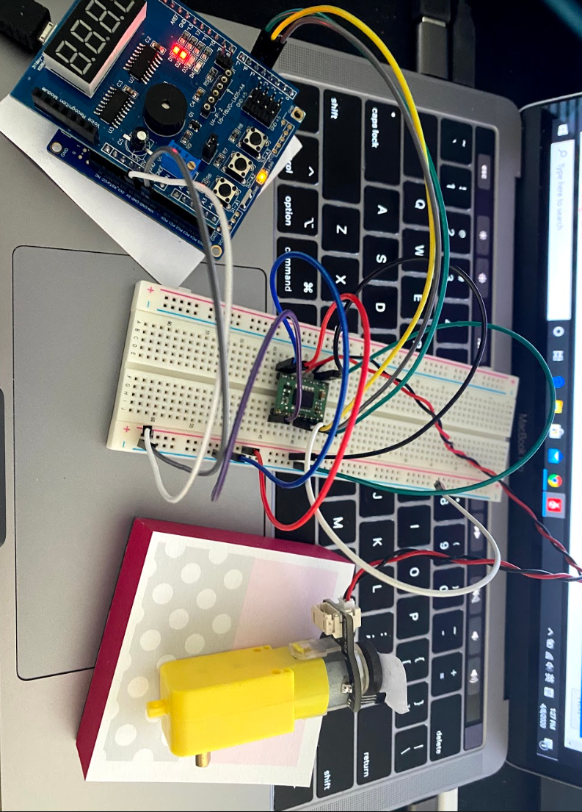

Task 3:

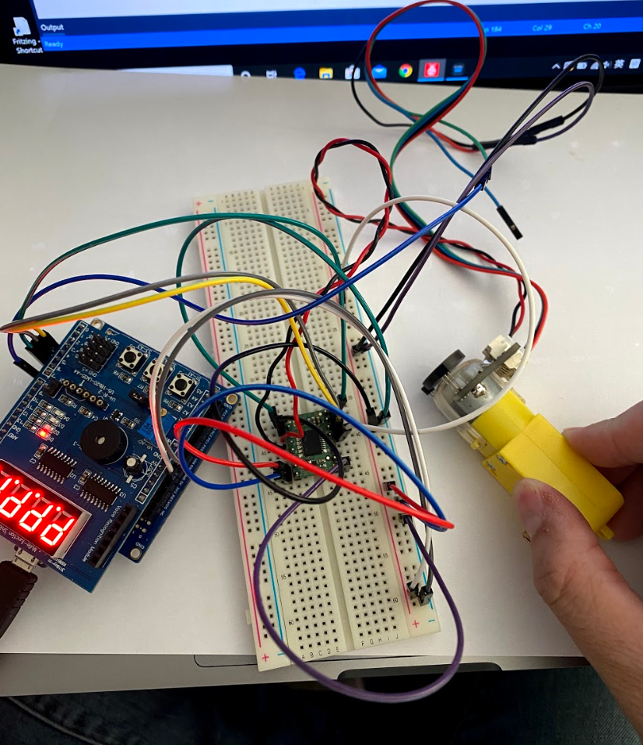

Task 4:

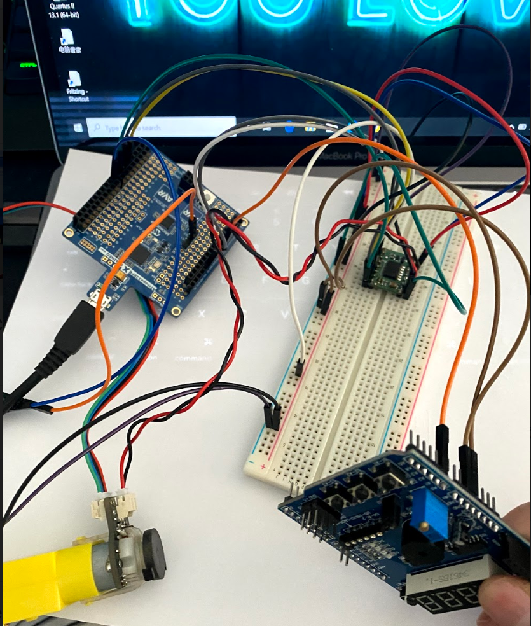

1. **VIDEO LINKS OF EACH DEMO**

Task 1: <https://youtu.be/Ng6VMq2XRT4>

Task 2: <https://youtu.be/dxA80agWcLc>

Task 3: <https://youtu.be/ekZuzCWtv3A>

Task 4: <https://youtu.be/4X7eyJI9g_A>

1. **GITHUB LINK OF THIS DA**

**Student Academic Misconduct Policy**

<http://studentconduct.unlv.edu/misconduct/policy.html>

“This assignment submission is my own, original work”.

Xianjie Cao